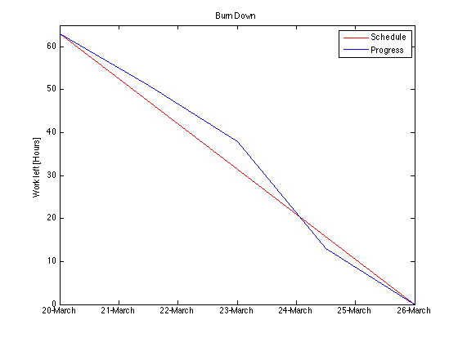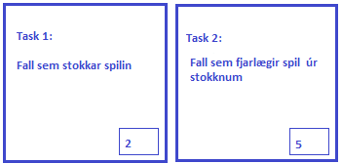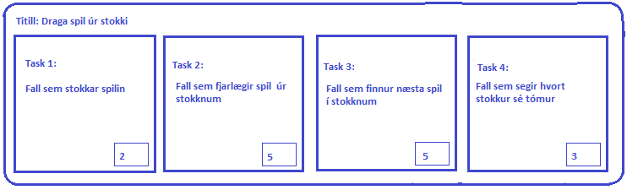

Burn Down

Complete

In Progress

User Stories

**llllllllllllllllllllllllllllllllllll**

**llllllllllllllllllllllllllllllllllll**

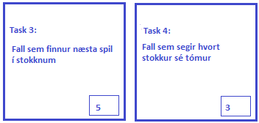

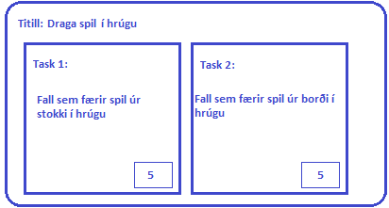

- - - - - - - - - - - - - - - - - - - - - - - - - - - - - - -

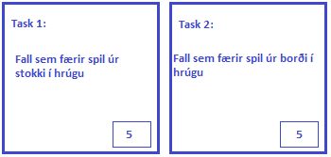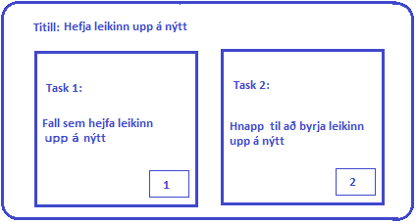

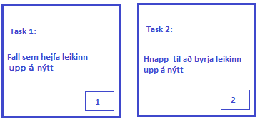

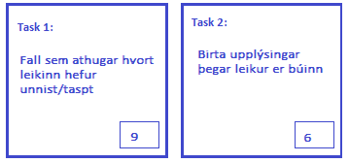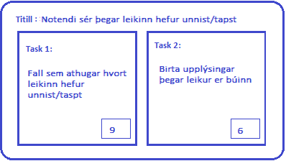

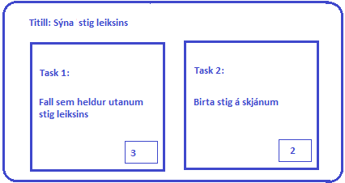

- - - - - - - - - - - - - - - - - - - - - - - -

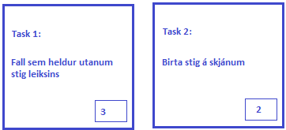

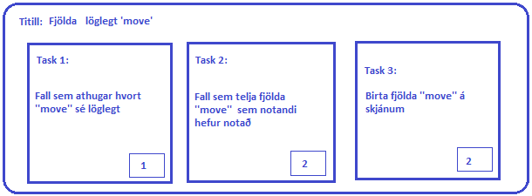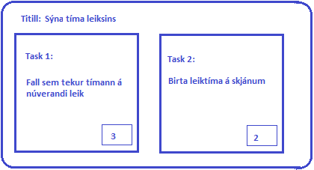

Burn Down

Complete

In Progress

User Stories

**llllllllllllllllllllllllllllllllllll**

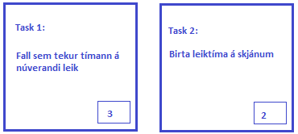

**llllllllllllllllllllllllllllllllllll**

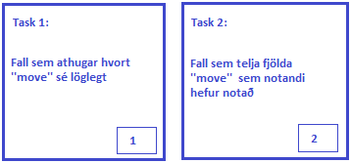

- - - - - - - - - - - - - - - - - - - - - - - - - - - - - - - - - - - - - - - - - - - - - -

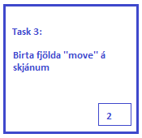

next

- - - - - - - - - - - - - - - - - - - - - - - - - - - - - - - - - - - - - - - - - - - - - - - - - - - - - - - - - - - - - - - - - - - - - - - - -- -

Completed

